Course Introduction Video

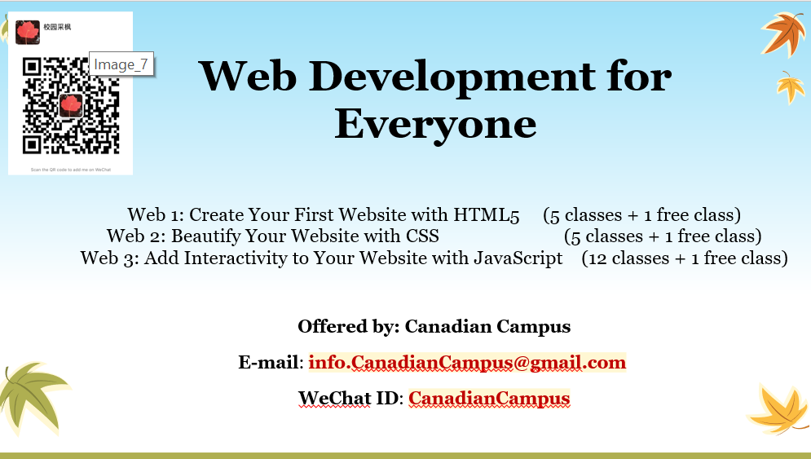

Web Development for Everyone

# Web 1: Create Your First Website with HTML5

# Web 2: Beautify Your Website with CSS

# Web 3: Add Interactivity to Your Website with JavaScript

Offered by: Canadian Campus

Instructor: Canadian College professor, PhD in Computer Science.

This video introduces the instructor and the three courses. It demonstrates what you will learn and what you can do in each course.

此视频介绍任课教师、三门课程大纲，演示您将学到什么，课后能够做出什么样的成果。

For more information, registration, and questions, please contact us at:

注册信息及更多资讯，请联系我们：

E-mail: [info.CanadianCampus@gmail.com](mailto:info.CanadianCampus@gmail.com)

WeChat ID: CanadianCampus

WeChat QR code:

